**Coppermine Chapter**

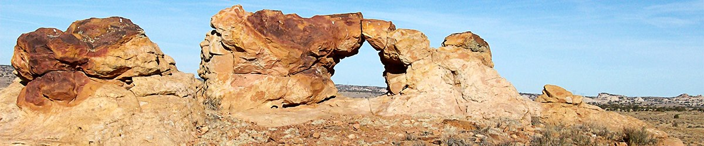

Regular Chapter Meeting

February 24, 2022 @ 3PM Teleconference

Join us by phone (US) 1+984-329-2568 PIN 139 122 833#

**MINUTES**

I. Welcome & call to order by:

II. Invocation by:

III. Review and Adopting the Agenda:

**Motion: Second: Vote:**

IV. Reading and Approval of Meeting Minutes to be posted at Chapter Administration Building:

**Motion: Second: Vote**:

V. Old Business:

A. None

VI. New Business:

A. Financials: Secretary/Treasury- vacant AMS- vacant

B. **RESOLUTION: CO-02-015-22**: AUTHORIZING THE APPROVAL OF THE CHAPTER SCHOLARSHIP

GENERAL FUND FOR THE FOLLOWING FIVE (5) FULL TIME STUDENTS IN THE AMOUNT OF $500.00

EACH UTILIZING SCHOLARSHIP GENERAL FUND 13:6721.

**STUDENTS SCHOOL**

1. Hailei Joe Coconino Community College

2. Simone Richardson Arizona State University

3. Chelsea Walker Grand Canyon University

4. Jalen Smallcanyon Dine’ College

5. Mariah Yazzie University of Antelope Valley

**Motion: Second: Vote:**

*Jalen Smallcanyon: Presented @ Planning Meeting

V. Reports and Presentations: (5 minutes allotted per subject)

1. Page Unified School: Fern Bigman Green

2. TCRHCC – Radiation Department: Natasha Begay

3. Community Health Representative: Susie Shorthair

VIII. Chapter Administration and Chapter Officials Report:

1. Council Delegate – Paul Begay

2. Chapter President – Allen Fowler Jr.

3. Chapter Vice-President – Lola Smith

4. Chapter Grazing Official – Stanford Fowler

5. CLUPC – Linda Long

IX. Announcements:

1. Next Planning Meeting March Teleconference @3pm

2. Next Chapter Meeting March Teleconference @3pm

3. Next CLUPC Meeting TBA

4. Next Grazing Committee Meeting TBA

X. Adjournment:

**Motion: Second: Vote:**